Ganesh sesha sai Akhil . Koutarapu

AP21110010931

CSE-O

**FRONTEND for CASE STUDY :**

1.Train:

CREATE TABLE Train (

Train_ID INT PRIMARY KEY,

Train_Name VARCHAR(100),

Departure_Station VARCHAR(100),

Arrival_Station VARCHAR(100),

Departure_Time TIME,

Arrival_Time TIME,

Total_Seats INT,

Available_Seats INT

);

Frontend output in html :

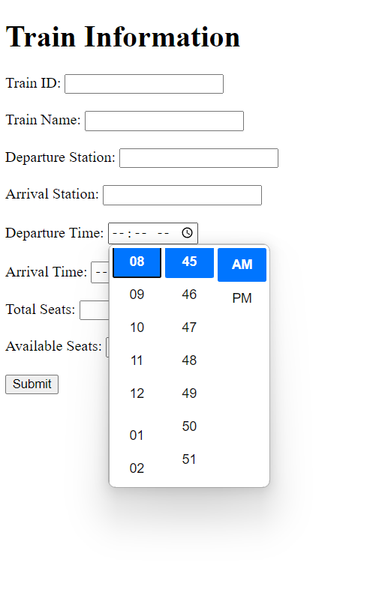

2.Passenger:

CREATE TABLE Passenger (

Passenger_ID INT PRIMARY KEY,

Name VARCHAR(100),

Contact_Number VARCHAR(20),

Address TEXT

);

Frontend output in html:

3.Reservation:

CREATE TABLE Reservation (

Reservation_ID INT PRIMARY KEY,

Passenger_ID INT,

Train_ID INT,

Seat_Number INT,

Date DATE,

FOREIGN KEY (Passenger_ID) REFERENCES Passenger(Passenger_ID),

FOREIGN KEY (Train_ID) REFERENCES Train(Train_ID)

);

Frontend output in html:

4.Ticket:

CREATE TABLE Ticket (

Ticket_ID INT PRIMARY KEY,

Reservation_ID INT,

Fare DECIMAL(10, 2),

Payment_Status VARCHAR(20),

FOREIGN KEY (Reservation_ID) REFERENCES Reservation(Reservation_ID)

);

Frontend outout in html:

5.Station:

CREATE TABLE Station (

Station_ID INT PRIMARY KEY,

Station_Name VARCHAR(100),

Location VARCHAR(100)

);

Frontend output in html :

6.Employee:

CREATE TABLE Employee (

Employee_ID INT PRIMARY KEY,

Name VARCHAR(100),

Position VARCHAR(100),

Contact_Number VARCHAR(20)

);

Frontend Output in html:

Frontend for all Tables:

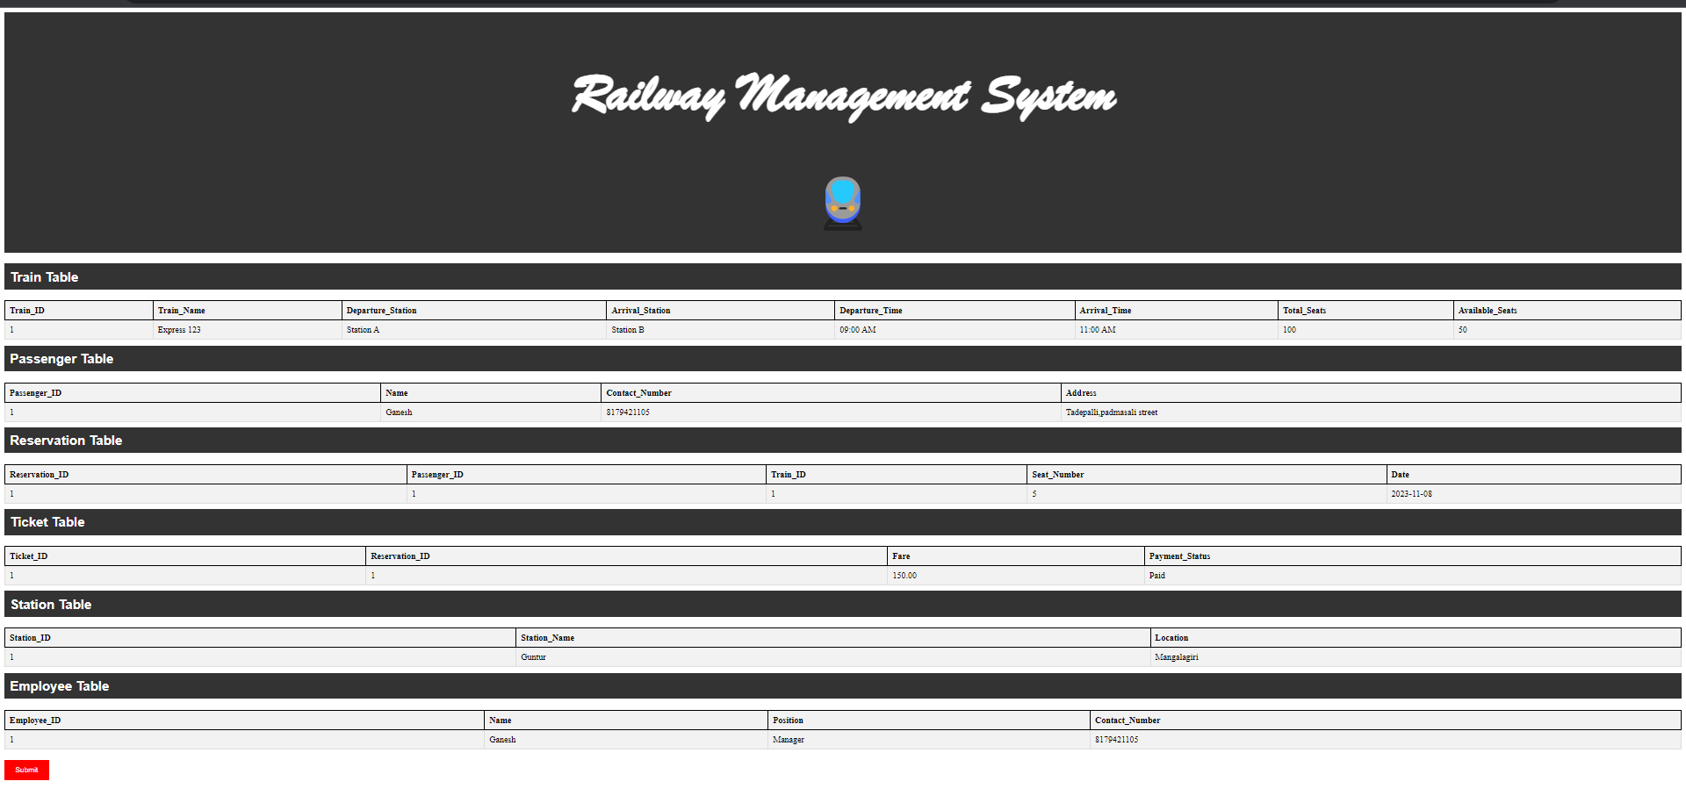

Code:

*<!DOCTYPE html>*

*<html>*

*<head>*

*<style>*

*/* Add CSS styles for your tables */*

*table {*

*border-collapse: collapse;*

*width: 100%;*

*margin-top: 20px;*

*border: 2px solid black;*

*background-color: #f2f2f2;*

*}*

*th, td {*

*border: 1px solid #dddddd;*

*text-align: left;*

*padding: 8px;*

*}*

*th {*

*background-color: #f2f2f2;*

*border: 2px solid black;*

*}*

*tr:nth-child(even) {*

*background-color: #f2f2f2;*

*}*

*/* Style the heading for each table */*

*h2 {*

*background-color: #333;*

*color: white;*

*padding: 10px;*

*margin: 10px 0;*

*font-family: Arial, sans-serif;*

*}*

*/* Style the submit button with red color */*

*input[type="submit"] {*

*background-color: red;*

*color: white;*

*padding: 10px 20px;*

*border: none;*

*cursor: pointer;*

*margin-top: 20px;*

*}*

*/* Style for the main heading */*

*.main-heading {*

*text-align: center;*

*background-color: #333;*

*color: white;*

*padding: 20px;*

*margin-bottom: 20px;*

*font-family: "Brush Script MT", cursive;*

*font-size: 50px;*

*}*

*/* Style for the train symbol */*

*.train-symbol {*

*text-align: center;*

*font-size: 100px;*

*}*

*</style>*

*</head>*

*<body>*

*<!-- Main Heading -->*

*<div class="main-heading">*

*<h1>Railway Management System</h1>*

*<div class="train-symbol">🚆</div>*

*</div>*

*<!-- Train Table -->*

*<h2>Train Table</h2>*

*<table>*

*<tr>*

*<th>Train_ID</th>*

*<th>Train_Name</th>*

*<th>Departure_Station</th>*

*<th>Arrival_Station</th>*

*<th>Departure_Time</th>*

*<th>Arrival_Time</th>*

*<th>Total_Seats</th>*

*<th>Available_Seats</th>*

*</tr>*

*<tr>*

*<td>1</td>*

*<td>Express 123</td>*

*<td>Station A</td>*

*<td>Station B</td>*

*<td>09:00 AM</td>*

*<td>11:00 AM</td>*

*<td>100</td>*

*<td>50</td>*

*</tr>*

*<!-- Add more rows here if needed -->*

*</table>*

*<!-- Passenger Table -->*

*<h2>Passenger Table</h2>*

*<table>*

*<tr>*

*<th>Passenger_ID</th>*

*<th>Name</th>*

*<th>Contact_Number</th>*

*<th>Address</th>*

*</tr>*

*<tr>*

*<td>1</td>*

*<td>Ganesh</td>*

*<td>8179421105</td>*

*<td>Tadepalli,padmasali street</td>*

*</tr>*

*<!-- Add more rows here if needed -->*

*</table>*

*<!-- Reservation Table -->*

*<h2>Reservation Table</h2>*

*<table>*

*<tr>*

*<th>Reservation_ID</th>*

*<th>Passenger_ID</th>*

*<th>Train_ID</th>*

*<th>Seat_Number</th>*

*<th>Date</th>*

*</tr>*

*<tr>*

*<td>1</td>*

*<td>1</td>*

*<td>1</td>*

*<td>5</td>*

*<td>2023-11-08</td>*

*</tr>*

*<!-- Add more rows here if needed -->*

*</table>*

*<!-- Ticket Table -->*

*<h2>Ticket Table</h2>*

*<table>*

*<tr>*

*<th>Ticket_ID</th>*

*<th>Reservation_ID</th>*

*<th>Fare</th>*

*<th>Payment_Status</th>*

*</tr>*

*<tr>*

*<td>1</td>*

*<td>1</td>*

*<td>150.00</td>*

*<td>Paid</td>*

*</tr>*

*<!-- Add more rows here if needed -->*

*</table>*

*<!-- Station Table -->*

*<h2>Station Table</h2>*

*<table>*

*<tr>*

*<th>Station_ID</th>*

*<th>Station_Name</th>*

*<th>Location</th>*

*</tr>*

*<tr>*

*<td>1</td>*

*<td>Guntur</td>*

*<td>Mangalagiri</td>*

*</tr>*

*<!-- Add more rows here if needed -->*

*</table>*

*<!-- Employee Table -->*

*<h2>Employee Table</h2>*

*<table>*

*<tr>*

*<th>Employee_ID</th>*

*<th>Name</th>*

*<th>Position</th>*

*<th>Contact_Number</th>*

*</tr>*

*<tr>*

*<td>1</td>*

*<td>Ganesh</td>*

*<td>Manager</td>*

*<td>8179421105</td>*

*</tr>*

*<!-- Add more rows here if needed -->*

*</table>*

*<!-- Add a submit button with red color -->*

*<input type="submit" value="Submit">*

*</body>*

*</html>*